
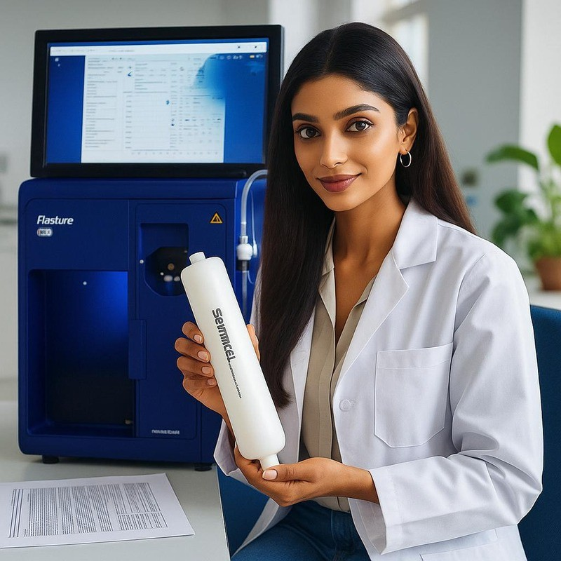


FLASHURE


Flashure Flash Columns
High-Efficiency Flash Chromatography Solutions
Manufactured by Ad Hoc Scientific Pvt Ltd

Introducing Flashure
Flashure is our premium range of flash chromatography columns, engineered to deliver fast, scalable, and reproducible separations. Built with high-purity silica and precision-packed for optimal flow and performance, Flashure columns support a wide variety of purification needs — from discovery labs to production units.


Product Categories

Normal Phase Flash Columns
Designed for non-polar compounds Packed with high-purity silica (60–120 Å)
Ideal for separations of non-polar to moderately polar molecules Low water content to ensure superior adsorption
Available in multiple cartridge formats and sizes
Applications: Organic compound purification, natural products, intermediate separation
Popular Sorbents: Silica, Amino, Diol, Cyano

Reverse Phase Flash Columns
Optimized for polar and aqueous-soluble compounds Modified silica with C18 or C8 bonded phases Compatible with water-rich and buffered mobile phases
Suitable for scale-up purification
Applications: Peptides, APIs, polar drugs, natural extracts Available Chemistries: C18, C8, Phenyl, Biphenyl

Ion Exchange Flash Columns
Separate based on charge interactions Strong & weak cation/anion exchange resins
High loading capacity
Excellent selectivity for charged analytes
Applications: Protein purification, charged drug molecules, biomolecule separations
Phases Available: SCX, SAX, WAX, WCX



Why Choose Flashure?
High-purity sorbents for reproducible separations Leak-proof design with optimized flow dynamics High sample throughput & low solvent usage
Wide compatibility with all flash chromatography systems
Available in cartridge sizes from 4g to 1kg+

Customization Available
Need a specific phase, particle size, or loading? Contact us for OEM or custom-packed column services tailored to your method development.

Request a Demo or Quote


+91-9096999799
info@adhocscientific.com www.adhocscientific.com

